- Identify the user is following the logon instructions.
- Select the link for Employee Portal Login.
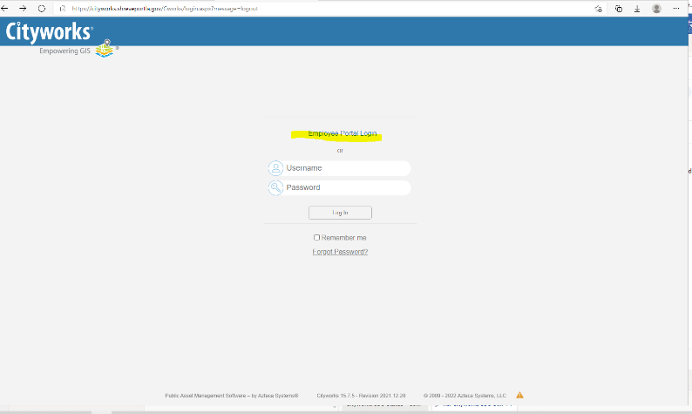
- Once the next window displays, click the Shreveport SSO button in the Enterprise logon area.
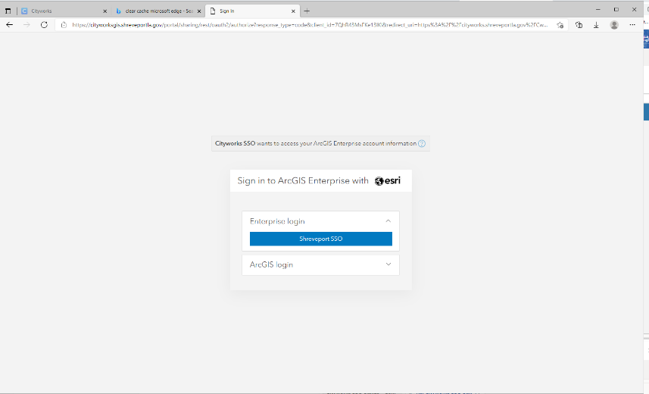

- a. If the Microsoft window to enter your email address appears, request the user enter his email address.
b. If the Microsoft window appears to enter your password, request the user enter his
Microsoft password.
c. Two factor authentication may be required, and the user is requested to enter a code that can be sent via text or a phone call to their phone number.
d. If the user does not remember their Microsoft email password, the Help Desk can assist.
(318) 673-5770.

- If the following ArcGIS Enterprise Portal – CW message appears:
- Within the Helpdesk ticket that was created for the issue, add a note and address it to Infrastructure – DJ Smith, JaMarjay Tooke, Brandon Spain to add the user to Active Directory (AD) group GIS_CW_SSO_Users.
- DJ Smith is the analyst who is most aware of the issue.
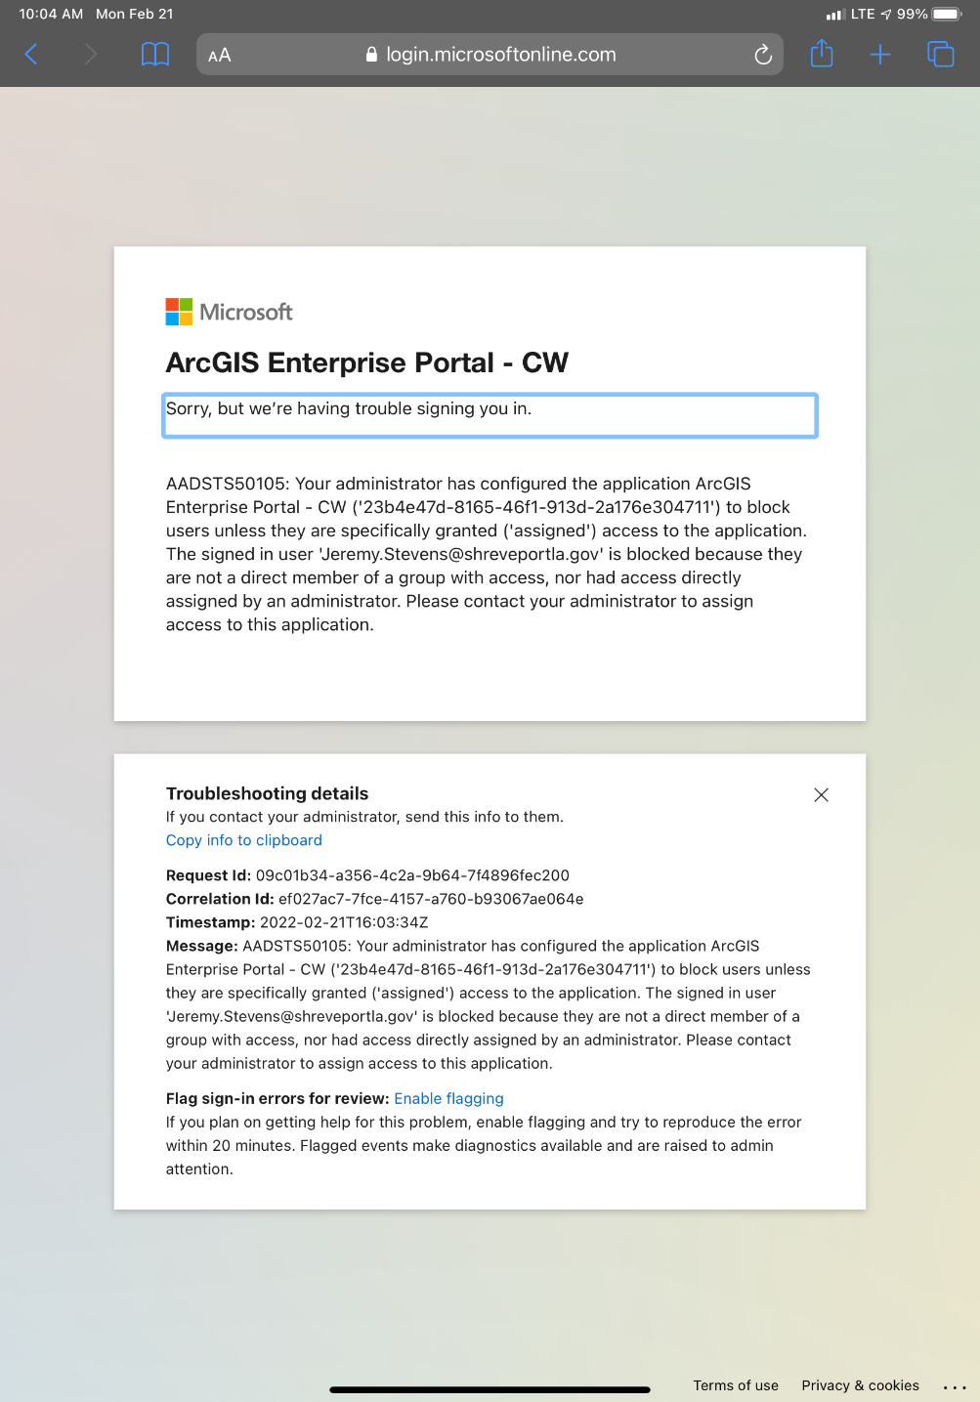
- Active Directory (AD) - Cityworks user group GIS_CW_SSO_Users Properties
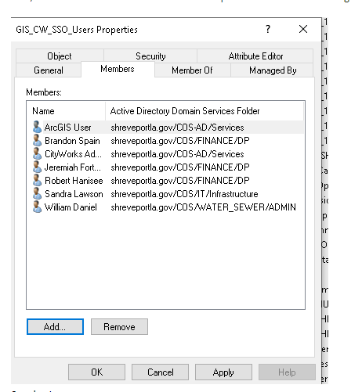

- MAP – Locate and Geocode functionality are not working.
- If there is a MAP issue, inform the user that the vendor has to perform additional configuration modifications and an email will be sent when the process has been completed.
